Alexis Prazak
3/14/2026
CS330 1-4 Final Project Review
Below is the picture being analyzed.
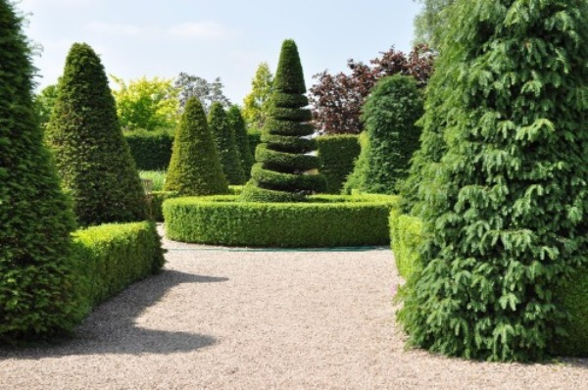
There are four major shapes in the photo. They all can be represented with variations of the following shapes:
- Cylinder: My first instinct was to use a pyramid, but using a tapered cylinder will keep the trees round shape.
- Torus: This will be used to create the prominent circular hedge in the center of the image.
- Prism: A rectangular prism would be best for the other bushes in the picture.
- Plane: A single 2D plane can be used for the ground.
Some shapes will need multiple shapes to bring them to life. The tree in the center of the picture can be made of multiple torus objects with a tapered cylinder at the top. Other objects can be simplified. Each tree won’t be made of individual leaves, but have textures to give that feel. Making hundreds of tiny objects can take a lot of processing power. When an image can get away with it simplifying is a good way to optimize.

